1. **Important Points in Practicum  
     
   1.1 Objectives of the Practicum**Integrating, synthesizing and applying knowledge and skills acquired at the Bestlink College of the Philippines School to a real-world problem or issue

Enhancing and developing skills needed to function in a professional Programming company setting, particularly:

– Problem solving and analysis

– Interpersonal skills

– Oral and written communication

Working on a substantive public health problem or issue that is salient to the sponsoring organization.

Engaging in professional self-assessment and critical reflection.

**1.2 Guidelines/Policy before Practicum**Students will work at a practice site in accordance with individual program requirements. In addition to the practice placement, students should meet on a regular basis with the course instructor and other students.

In general, for practice placements during the academic year:

Students are advised to search for a practice placement 3-6 months before the practice is to begin

- 3-8 hours per day, around 500 hours total.

- 1 to 2 semesters in length depending on program requirements.

- Summer practicums are typically full time.

1. **The Workplace  
     
   2.1 Company Profile  
     
   2.1.1 Company History  
     
   HISTORY OF BESTLINK COLLEGE OF THE PHILIPPINES  
     
    BESTLINK COLLEGE OF THE PHILIPPINES** (formerly Bestlink Institute of Information Technology) was established in June 2002 at Sacred Heart Village, Caloocan City by the generous and charitable Madame Mary M. Vicente, President, and Engineer Reynaldo Corpuz, Administrator.  
    The school was initially named “LOG-ON-TODAY”, but the management decided to change it. Inspired by the phrase, **“Be trained to be the best: be linked to success”, BESTLINK** was made. Since Bestlink offers computer-based courses it was decided to be named as **BESTLINK INSTITUTE OF INFORMATION TECHNOLOGY.** With its aim to provide holistic training, Bestlink started with four (4) TESDA-accredited computer access. (1) Computer System Design and Programming, (2) Computerized Office Management, (3) Computer Technology and Networking, and (4) Computer Graphics and Web Development.  
   Bestlink started with seven (7) students and four (4) faculty members. It has undergone ferocious problems but Bestlink remain strong and retained its courage.  
   Now that the school has gained success through the years, Bestlink has indeed proven its desire to excel in the cause of taking functional and educational leadership in the tertiary level. **2.1.2 Company Mission and Vision**  
   **MISSION:** To produce self-motivated and self-directed individual who aims for academic excellence, God-fearing, peaceful, wealthy, productive and successful citizens.  
     
   **VISION:** Provide and promote quality education through unique, modernized and research-based techniques and delivery system in a teaching learning process (TLP).

**GOALS:** Bestlink College of the Philippines puts God in the center of all its efforts to realize and operationalize its vision and missions through the following goals:

1. **Instruction**

* Utilize upgraded curriculum of the different programs to facilitate complementary knowledge demanded by the global community;
* Use the expertise of qualified faculty for the different fields of specialization relevant to the different program offerings of BCP;
* Provide the use of sufficient and modern instructional materials, updated and safe facilities equipped with technologically advanced equipment, gadgets tools and others;
* Facilitate the needed exposures of learners related to their course requirements, through significant linkages and networks; and
* Incorporate value-laden topics and lessons in all learning opportunities necessary to produce humane learned graduates.

1. **Research**

* Facilitate research opportunities and challenges to the faculty, students, and personnel through the design, improvement, development, and others, pertinent to both instructional and non-instructional concerns of BCP and its academic community; and
* Make use of research as a BCP mode of promoting network and linkages with other entities for scholarly pursuits and twinning efforts towards problem solutions, technology advancement, crises management, productivity endeavors, and others.

1. **Extension**

* Mobilize entire BCP community in an extension service partnership with an identified deprived, depressed, and underserved (DDU) community;
* Actively participate in the fulfilment of the academe’s social involvement to facilitate a chance to DDU community partner for an opportunity towards sustainable development;
* Facilitate extension services to less fortunate community partner/s for sustainable return to the enjoyment of better life; and
* Facilitate empowering skills and competencies from BCP to the identified community partner/s.

1. **Productivity**

* Facilitate productivity schemes incorporated within the program’s curriculum offerings;
* Create networks and linkages between the school and entities that may provide employment opportunities, entrepreneurial chance, and
* business capacities, for guidance, and information dissemination to its learners, graduates, faculty, and staff;
* Oversee and monitor all income generating projects (IGP) efforts; and
* Maintain active teamwork with Research and Development (R & D) unit of BCP to search and work on, possible productivity ventures of the school.

**OBJECTIVES:** Adhering to the Philippine Constitution and imploring the aid of the Divine Providence, Bestlink College of the Philippines aims to:

1. Provide needed and excellent instruction within reach of learners, and which is sustained to answer the demands of both domestic and global market;

2. Produce graduates who are skilled, competent, self-motivated and directed, ready to face the challenges of a fast-paced life;

3. Supply the world with humane, God-fearing, values-laden and progressive graduates, to be ideal citizens of the Community of Men;

4. Continue its endeavors in research for furtherance of the quality education BCP delivers through the academe;

5. Facilitate extension services to less fortunate community partner/s, for sustainable return and the enjoyment of a better life;

1. Maintain manpower of experts to operationalize the Vision, Mission, Goals and Objectives of BCP.

**2.1.3 Company Core Values  
  
Philosophy:** Faith, Knowledge, Charity and Humility  
  
 **FAITH** (Fides) represents BCP’s endeavor for expansion development and growth amidst the global challenges of the new millennium. It is moving forward and lifting its fate to the hands of God, for without His guidance, BCP cannot do and deliver affordable quality education and multiply God’s graces especially to the less fortunate youth of the land.

**KNOWLEDGE** (Cognitio) connotes the institution’s efforts to impart excellent lifelong education that can be used as human tool so that no one can liberate himself/herself from ignorance and poverty. Hence, all its academic offerings are relevant tools to empower man to effectively use one’s reason, intellect and will to face the challenges of life.  
  
 **CHARITY** (Caritas) is the institution’s commitment towards its clienteles. Sharing and services are the insignia of its soul, the badge of its character.

**HUMILITY** (Humilitas) refers to the institution’s recognition of its human frailty, its imperfection. But in its imperfection, it learns how to move forward and learn from the do’s and don’ts of life. Simply stated: it is humble to proud and proud to be humble.

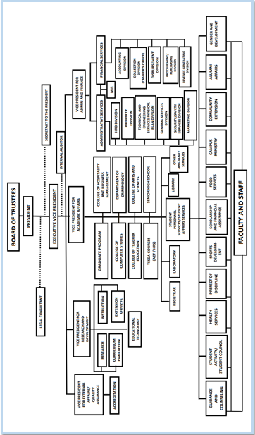**2.1.4 Company Organizational Chart** *Figure1. BCP Organizational Structure* **2.2 Department Profile  
  
Alumni Office** It is an office that re-connects the school with graduates. These graduates are provided with information about the progress and projects of the school. Likewise, they are invited to support and/or to donate, contribute whatever assets they have, cash or in kind.  
  
- Establishes contact among the alumni members for mutual assistance in their personal and professional development.  
- Organizes the members’ collective efforts in assisting their Alma Mater in the fulfillment of its academic mission as a world class institution for higher education.  
- Cultivates and foster close fellowship among the alumni through gathering and socio-civic activities.  
- Provides a forum whereby the various disciplines could be integrated meaningfully with the larger Filipino society and upon which concrete, viable action can be based.  
- Encourages the formation of professional, regional, geographical organizations of the alumni community. **2.2.1 Department History  
  
INTRODUCTION**

The **BESTLINK ALUMNI ASSOCIATION OFFICE** was established in November 2017, due to the Continuing expansion of the Institution. It was created in preserving a positive relationship with the alumni and maintaining communication channels with the alumni to have a continuous linkage in order to develop camaraderie.

The Association will cater the establishment of rapport, unity and responsible citizenry that will be responsive to the needs of Alumni, entire community as social interaction and willingness to provide service and support to strengthen and advancement of the institution.

The effectiveness of the Alumni Association is providing continually dynamic leadership opportunities through professional experience and diverse personal and cultural backgrounds for the benefit of the Alumni Association and Institution would be a great help in benefit of the Alumni Association and Institution would be a great help in ensuring the development of all the entities related in the Association.

The Association would like every BCPians to be part of the Institution’s future, not just its past.

**2.2.2 Department Mission and Vision  
  
BESTLINK ALUMNI ASSOCIATION**

**MISSION:** To provide an effective Alumni Association by continually infusing dynamic alumni leadership that provides professional experience, creative thinking, open-mindedness and diverse personal and cultural backgrounds for the benefit of the Alumni Association and Institution.  
  
**VISION:** The Bestlink Alumni Association aspires to be an organization responsive to the needs of alumni relative to their careers, desire for lifelong learning and engagement, social interaction, and willingness to provide volunteer service and/or support to strengthen and advance the institution.

**2.2.3 Department Core Values**Establish contact among the alumni members for mutual assistance in their personal and professional development.

1. Organize the members’ collective efforts in assisting their Alma Mater in the fulfillment of its academic mission as a world-class institution for higher education.
2. Cultivates and foster close fellowship among the alumni through gathering and socio-civic activities.
3. Provide a forum whereby the various disciplines could be integrated meaningfully with the large Filipino society and upon which concrete, viable action can be based.
4. Encourage the formation of professional, regional, geographical organizations of the alumni community.
5. Undertake revenue-raising activities to fund its projects, provided that no part of its net income shall inure to the benefit of a private person or entity.

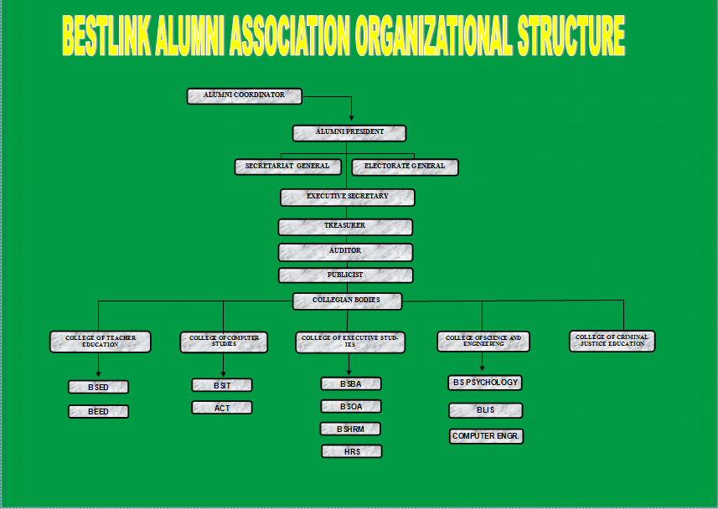 **2.2.4 Department Organizational Chart**

*Figure3. Alumni Association Organizational Structure*

**2.3 Product/Services Description  
2.3.1 Company/Department Logo and Its Meaning**

*Figure2. Alumni Association logo*  
  
 The official seal of the Association shall have the following specifications.  
 It shall contain a shield which symbolizes the oath of defending and strengthening the vision and mission of the Bestlink College of the Philippines. A pillar is attached in the center of the shield symbolizes the foundation and privilege given by the College to all its alumni members. On the upper center of the shield bears the insignia of the College echoes the crowning glory of alumni. The background of the logo bears an abstract laurel leaves in an igniting perspective which pertains to the five core values of the alumni which is faith, hope, love, wisdom and truth.

**2.3.2 Company/Department Partner/Affiliation**

**2.3.3 Company/Department Target Clientele**

1. Manages the Alumni Relations Office to ensure that it is operating in an efficient manner to advance the **BCP VMGO**, as well as the strategic direction of the Alumni Association;
2. Develops an annual plan outlining the goals and objectives of the alumni relations program aimed at maximizing alumni interest in and involvement with the school and its various entities;
3. Works in conjunction with the **SPS Director** in the planning and direction of Homecoming including targeted communication and marketing strategy; and
4. Recruits key volunteers and organizes volunteer activities.

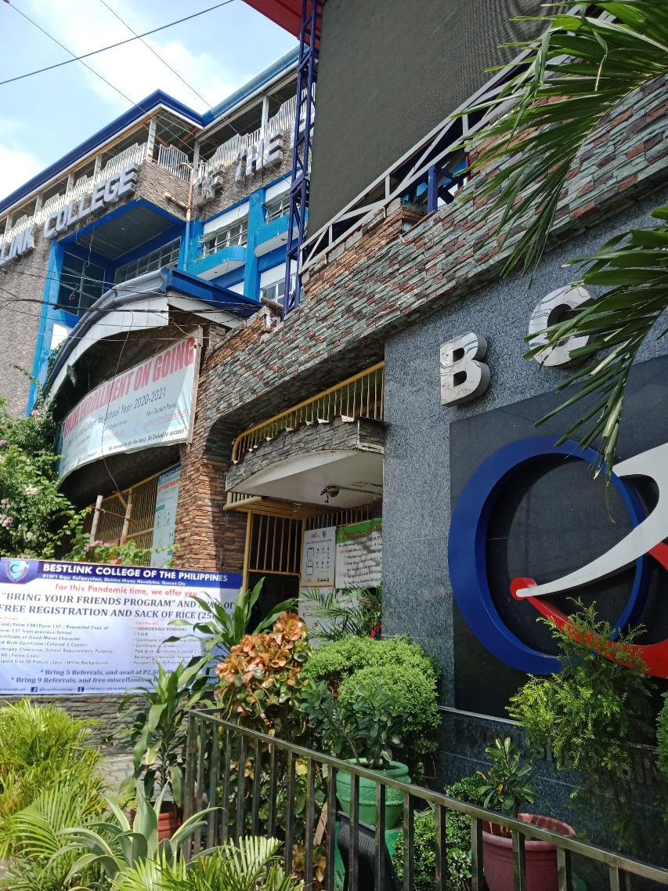**2.4 Location of Company**

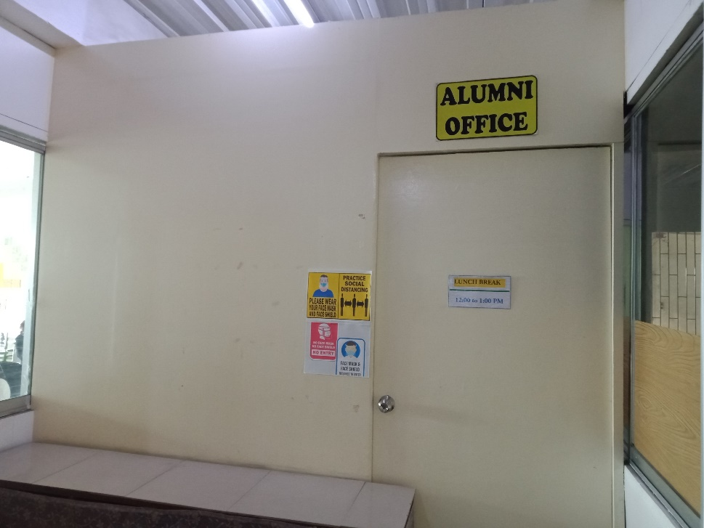

***Front view of the Bestlink Alumni Association Office***

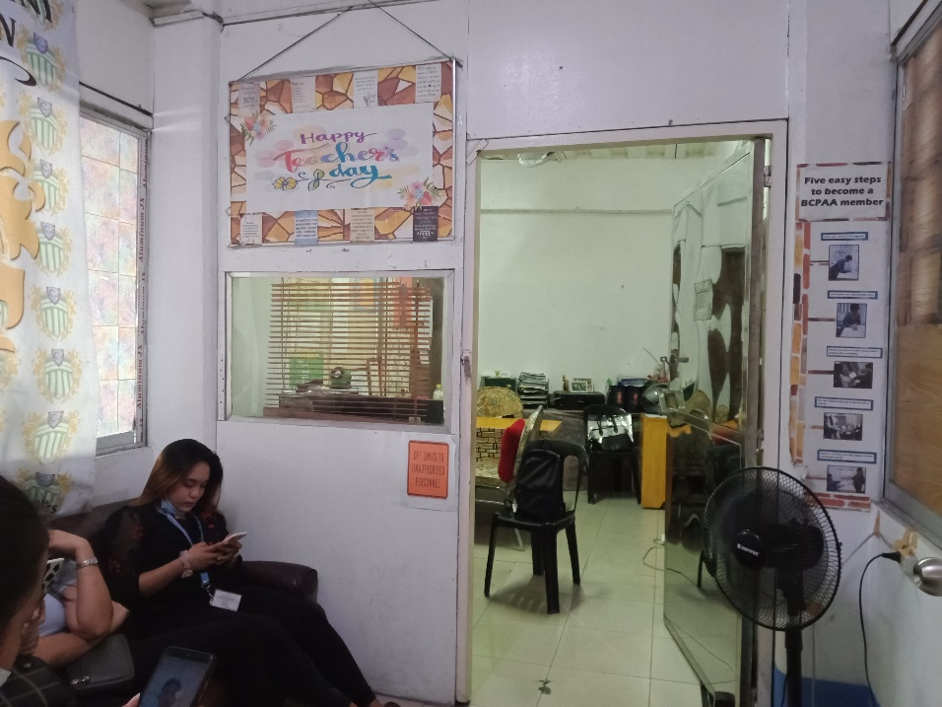

***Receiving Area of the Alumni Office***

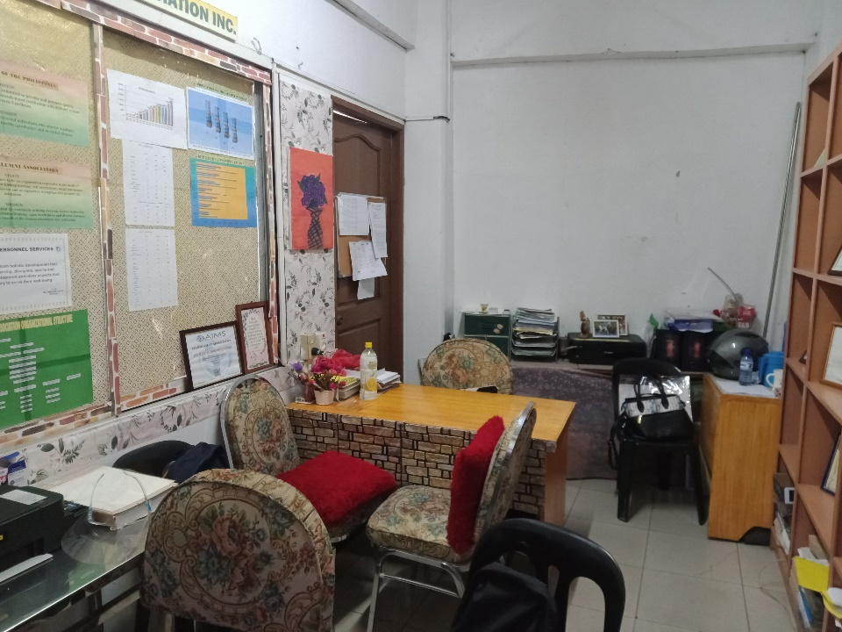

**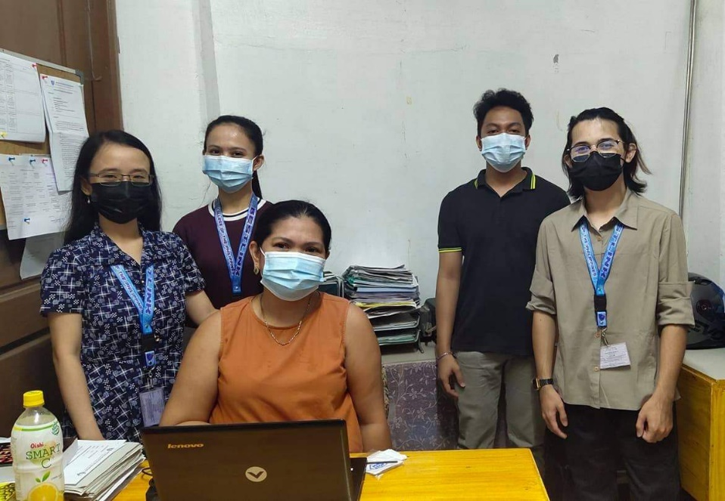 *Inside part of the Bestlink Alumni Association***

**2.5 Thrusts and Policy Directions  
  
2.6 Company Rules and Regulations**

As a student/scholarship grantee of this institution, I commit to abide by the school's policies, procedures, rules and regulations as set forth in the **STUDENT HANDBOOK**, specifically the following statements below.

1. I shall live up to the school's vision, mission, institutional goals, core values, and advocacies.

2. I shall **MAINTAIN GOOD BEHAVIOR** befitting of a student in and off campus.

3. I shall be respectful in my interaction with school administrators, teachers, other school personnel, parents, and visitors.

4. I shall refrain from saying inappropriate, disrespectful, and foul words in dealing with the people around me.

5. I shall refrain from speaking negatively about other people, including other schools, in any way.

6. I shall report to proper school authority cases or incidents that violate the stipulations above.

7. I shall consider myself responsible for the content I posted **ONLINE**.

7:1 I shall refrain from sending inappropriate or malicious images, videos, and messages to classmates, school mates, friends, teachers, and school in general.

7.2. I shall not engage in **ONLINE BEHAVIOR** that might be interpreted as dishonest, indecent, immature, rude, disrespectful, discriminatory, violent, arrogant, immoral, or aggressive

7.3. I shall refrain from engaging in arguments and inflammatory debates whether **ONLINE OR IN PERSON**. 741 shall not **UPLOAD OR SHARE** inappropriate images, videos or messages.

7.5. I shall not express concerns/ complaints towards the institutions, administrators, teachers, other employees. parents/guardians, and students using social media platforms. Instead, I shall confront concerns accordingly and in person, seeking assistance from my teacher/s or administrators, when necessary.

**Always remember, a person who places A PHOTO, VIDEO, or MESSAGE on the INTERNET is deemed to have intended to forsake and renounce all privacy rights to such imagery or text.**

Any violation of the agreement above will be subjected to appropriate disciplinary action as stipulated in the **STUDENT HANDBOOK** Likewise as a scholar of this institution my scholarship will be deemed null and void and shall be forced to pay the school's required **TUITION FEE.**

1. 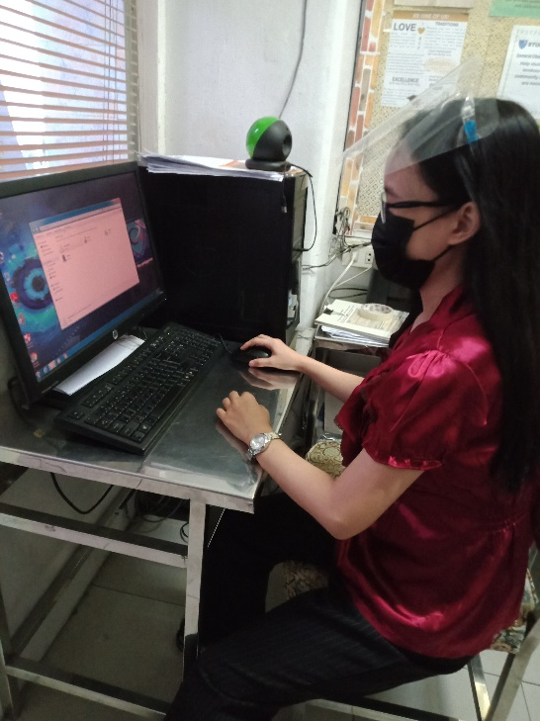**Activity Report  
     
   3.1 Daily Accomplishment Report  
     
     
   Day 1**

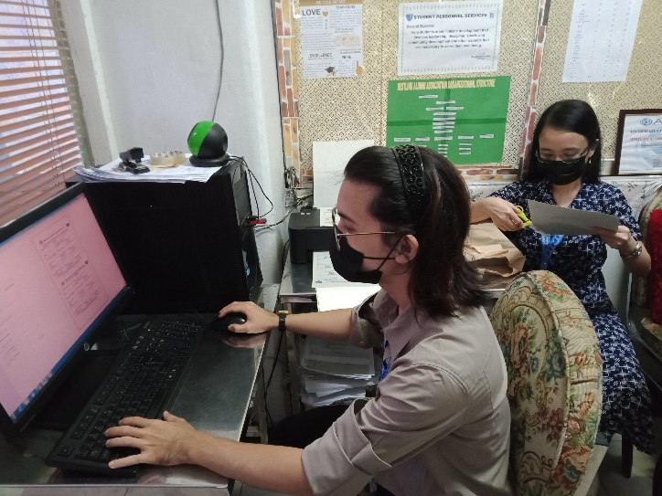**Day 2**

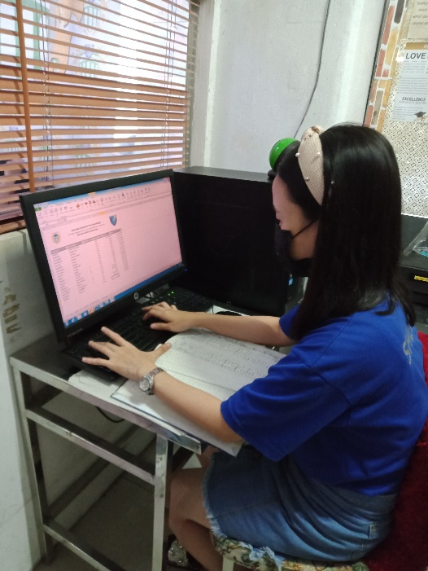**Day 3**

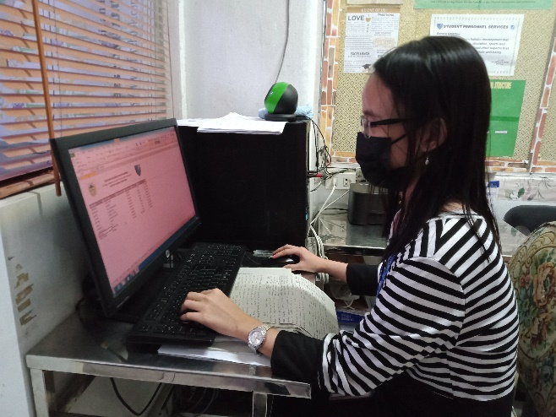

**Day 4**

**Day 5**



**Day 6**

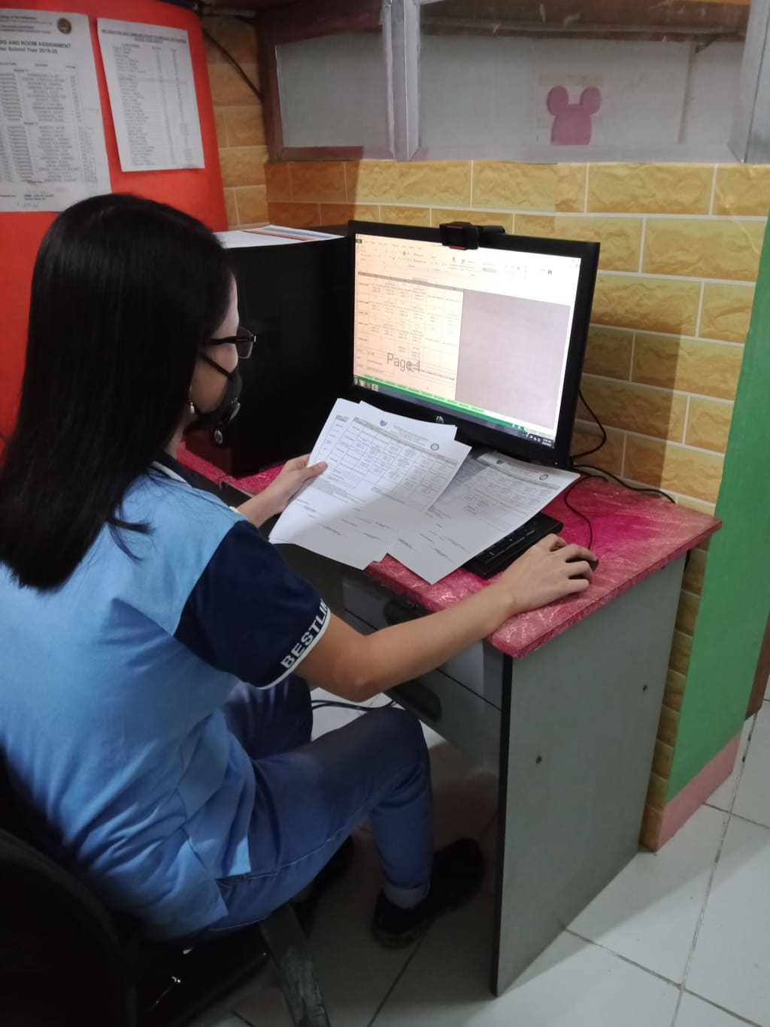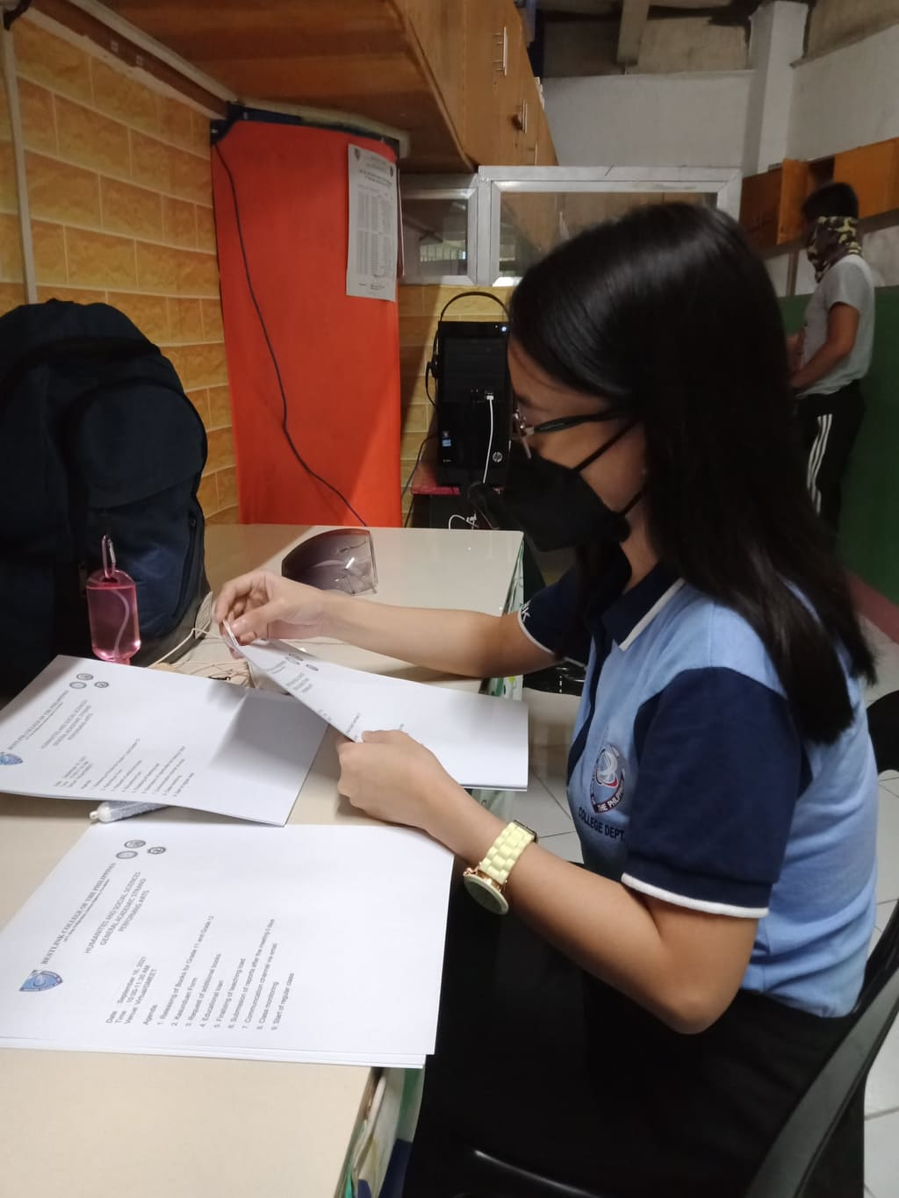**Day 7**

**Day 8**

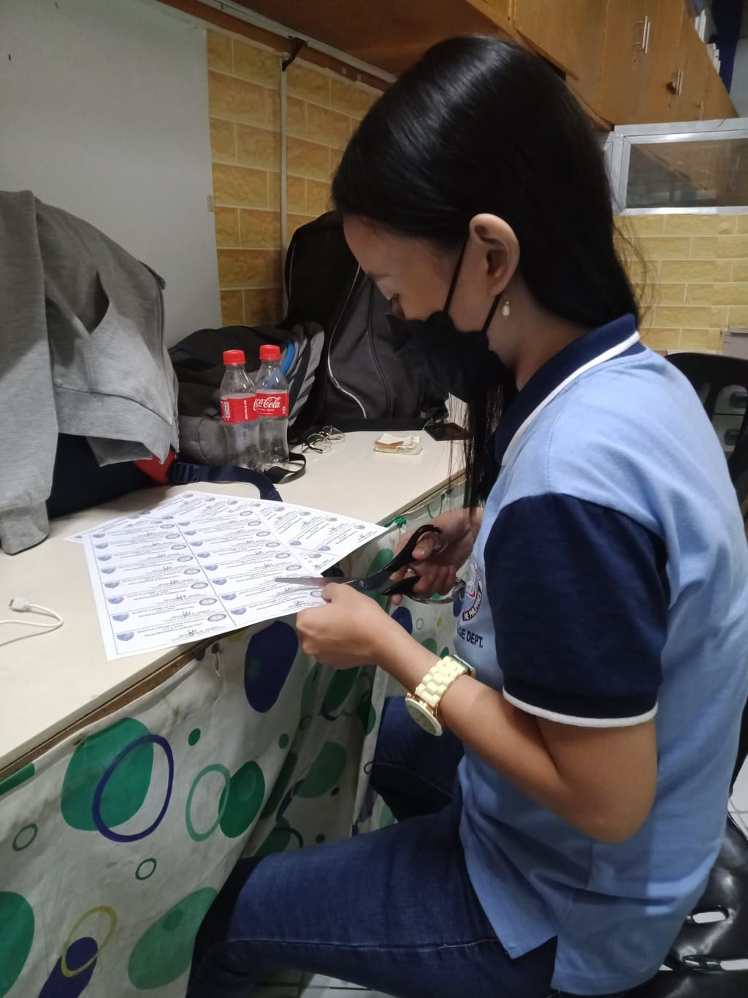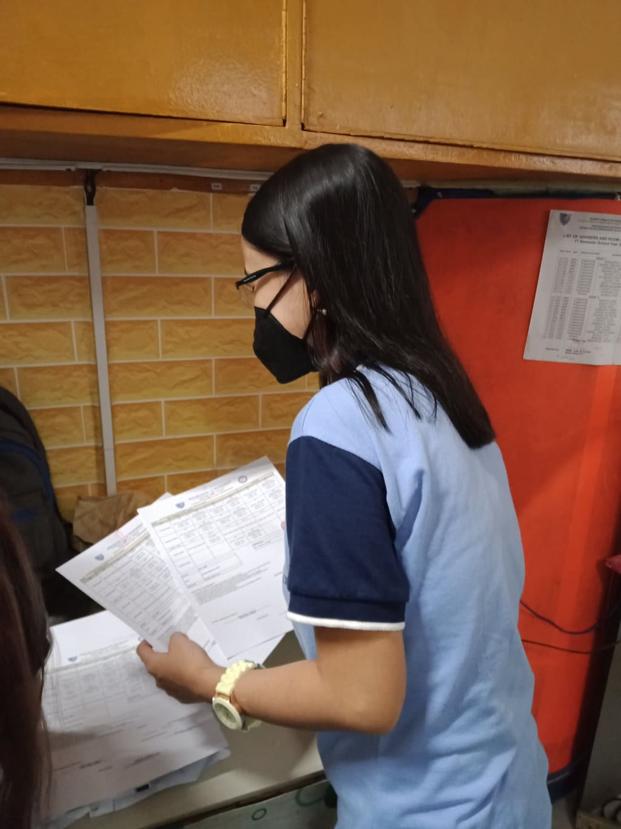**Day 9  
  
  
  
  
  
  
  
  
  
  
  
  
  
  
  
  
  
  
  
  
  
  
Day 10**

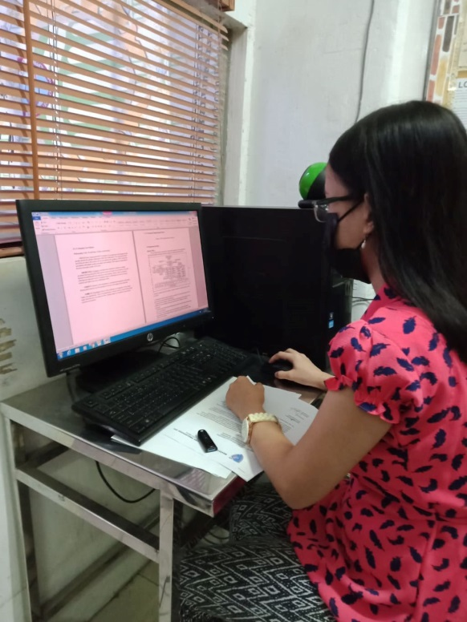**Day 11**

**3.2 Performance Appraisal Report**

1. **Reflection  
     
   4.1 Practicum Learning  
   4.2 Problems Encountered  
   4.3 Suggestions and Recommendations**